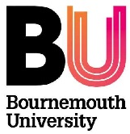
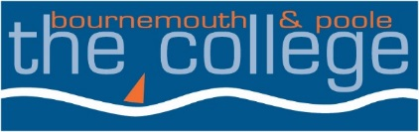
Higher Education
Date: 23 April 2018
The Bournemouth and Poole College
North Road, Parkstone, Poole, Dorset, BH14 0LS
Tel +44 (0)1202 747600

You are cordially invited to the

CGI Expo 2018
Bournemouth & Poole College in Association with Bournemouth University
Tuesday 12th June 2018 - 11.00am to 7.00pm
Digital Design Centre, Bournemouth & Poole College, North Rd, Poole, BH14 0LS

BSc Hons Degree & Foundation Degree 3D CGI Modelling & Animation and CGI Architectural Visualisation.

The CGI EXPO is a celebration of our students’ achievements, showcasing their work in the field of Computer Generated Imagery, covering modelling, animation and architectural visualisation. Students from all years will be presenting their work, with final years hoping to enter either a one-year placement or a full-time post in the CGI industry.

This is an excellent opportunity for those looking to recruit in the field of Computer Generated Imagery; those who wish to make connections for their own schools and colleges; and those who are interested in further study. There will be plenty of opportunity to chat or interview students - or just browse.

We welcome you to join us to watch these talented students’ animated shorts, and visualisations, and help celebrate their achievements.

The CGI Team,

Cathy Cheyne Mark Lloyd Kurt French Yulia Gleed Alex Scott

RSVP: Maryke Reilly (e-mail reillym@bpc.ac.uk or telephone 01202 205648)

Follow or contact us on:

Email - cgi@thecollege.co.uk Blog - Thecollegecgi.wordpress.com Twitter -@thecollegecgi

